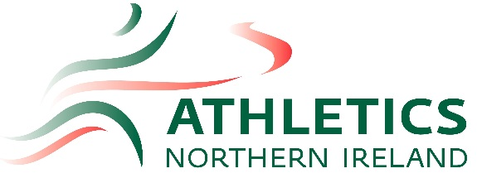
Athletics Northern Ireland International Representation Pathway Information

This document has been produced to keep athletes, coaches and parents within Northern Ireland informed of their choices in relation to Northern Ireland athletes’ unique dual nationality position. The information below outlines the choices Northern Irish athletes have when they are ready to make representative decisions.

Northern Ireland Representation

Currently, the Commonwealth Games and Commonwealth Youth Games are the only events where Northern Ireland athletes represent Northern Ireland. The Commonwealth Games and Commonwealth Youth Games occur every four years. Selection is made by the relevant Committees. The Commonwealth Games includes Olympic disciplines plus some Para events and the Commonwealth Youth Games includes events sanctioned by the International Amateur Athletics Federation (IAAF) for U18s. Athletics NI nominate athletes for these Championships and those nominations are then put forward to the Northern Ireland Commonwealth Games Council, which is responsible for selecting the Northern Ireland Commonwealth Games Team.

Athletes may represent Northern Ireland at multi-sport events such as the UK School Games and athletes may also represent Northern Ireland & Ulster in competitions, such as Home International Championships, and invitational internationals such as the Manchester International.

Northern Irish athletes will only achieve representation status when selected for an approved Athletics Northern Ireland (ANI) event, having gone through the selection procedure involving Athletics NI.

Regional and National Schools competitions are not ANI sanctioned events as athletes are representing their school and not ANI.

Selection Policies for events are available to view via the Athletics NI website here:
https://athleticsni.org/Athletes/Competition-Opportunities

The ANI Director of Coaching and Athlete Development, Jackie Newton, can be contacted at jackie@athleticsni.org and the Athlete Development Lead, Tom Reynolds, can be contacted via email at tom@athleticsni.org

British and Irish Representation

Northern Ireland athletes can choose to represent either ‘Great Britain & Northern Ireland’ or ‘Ireland’ if they meet the representation and selection criteria as laid out by British Athletics or Athletics Ireland respectively. An athlete from Northern Ireland can only represent one country.

Once an athlete is selected for and represents a country they will have been deemed to have declared their nationality for that country.

Please refer to the website for each governing body for specific performance criteria, scores, staff contact details and any additional conditions for selection:
British Athletics website – https://www.britishathletics.org.uk/
Athletics Ireland website - http://www.athleticsireland.ie/
Nationality Transfer
There have been incidences where athletes have decided to change their nationality. This requires approval from and the following documentation:

Governing Body who athlete is moving from (Former Federation)
- One official letter duly signed by the President and/or the Secretary General of the former Federation
Governing Body they wish to declare for (New Federation)
- One official letter duly signed by the President and/or the Secretary General of the new Federation

All cases are reviewed individually by IAAF. Nationality transfers may not take place more than once and a there is a minimum three-year waiting period before an athlete may transfer to represent another member. No transfers can take place before the age of 20.

Governing Body Pathways: The information below explains the different stages of the British and Irish Pathways. Athletes can only sit on one pathway. Please note that either governing body may change their structures, or refer to age groups differently, with variances occurring across the disciplines. Please refer to the respective websites for accurate, up to date information as this has been produced to provide guidance only.

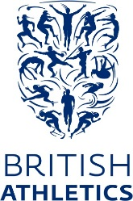
Additional Information for British Athletics:
Once an athlete has elected to represent another nation they will no longer be able to compete at the British Championships unless the Championships are incorporated into another event, in which case, they will not feature in the results of the British Championships element of the competition.

Eligibility:
Athletes are eligible for consideration provided they are:
- A British Citizen holding a United Kingdom passport
- Registered with one of the four home countries
- the minimum age and have met the relevant selection criteria

British Championships Eligibility:
Only those in possession of a valid United Kingdom passport are eligible to be ranked in the official Competition results, where a British Championships title is being contested. This is effective for individual competitions. In team competitions or where athletes compete together as part of a team, all of the athletes must be in possession of a valid United Kingdom passport in order for that team to be ranked in the official Competition results.

Selection Policies:
For Selection Policies please got to:
https://www.uka.org.uk/performance/2018-selection-policies/

World Class Programme:
The British Athletics World Class Performance Programme (“WCPP”) is UK Sport’s National Lottery funded initiative to support the delivery of success at the world’s most significant sporting events, principally the Olympic and Paralympic Games.
During the Tokyo cycle, the aim of the Olympic WCP is to win medals at the Olympic Games, whilst the Paralympic programme is focused on Gold medals. The WCP is structured to reflect these overall aims, as well as supporting the longer-term growth of the sport, and the need to achieve sustained success in Paris and beyond. As a result, the WCP is split into two distinct sections – “Podium” and “Podium Potential". Athletes currently just below WCP level will be considered for the British Athletics Futures Academy Programme.
Membership of the British Athletics WCP is conditional upon athletes entering into an Athlete Agreement. This agreement reflects the fact that the World Class environment is about achieving excellence in everything we do, from meeting challenging performance targets on the sports field to managing ourselves to the highest professional standards. It summarises the services that British Athletics will provide to the athletes and outlines the responsibilities that our leading athletes are expected to observe.
The funding year for the WCP runs from 1st December to the end of November each year. British Athletics conduct a review of each year (currently in October) during which they appoint a selection panel to assess whether athletes should be granted funding for the following year. To decide which athletes should be supported for the following year, the selection panel follow a selection policy (different policies are published for the Olympic and Paralympic programmes), which is available here. Athletes on the Olympic and Paralympic WCP are then be assessed on an ongoing basis to ensure that they continue to meet their targets, and that they maintain realistic medal potential for the future.

Athletes are encouraged to read the WCP Athlete Handbook which outlines the programme including support services, the National Performance Institute, Clean Athletics, Welfare and much more. Please take a read of the document here.

World Class Podium
Youth Academy/ Development Squads
Commonwealth Ambition
World Class Podium Potential
Futures Endurance
Futures Sprints, Relays & Hurdles
Futures Throws, Jumps & Combined Events

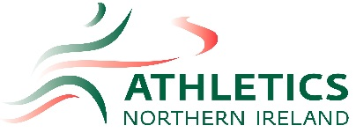
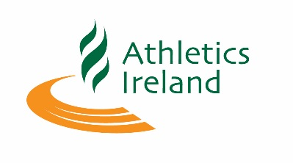
Additional Information for Athletics Ireland:

International Representation: In order to represent Ireland, or be eligible to become an Irish Champion, an athlete must hold, or be eligible to hold an Irish passport.

Irish Championships Eligibility:

National Championships

Title Holder Individual or Team (top three finishers individual or team members in track & field, indoor, cross country and road) -
An athlete must be a holder of, or eligible to hold an Irish Passport.
An athlete must be a member of an affiliated club on the Island of Ireland.
And, Or An athlete must reside on the island of Ireland for a minimum of 6 consecutive months immediately prior to the relevant championships
Carding

To be eligible for the OGPP an athlete must meet with the following requirements:
-Must possess Irish passport and satisfactorily demonstrate that they will be eligible to compete in an
Olympic Games, IAAF and or European Championship event for Ireland.
- Must be a registered member of Athletics Ireland.
- Must not be under suspension or other sanction by IAAF or Athletics Ireland

Competition Information and Selection Policies:

All athletes must submit the National Team Declaration Form by the policy deadline in order to be considered eligible for selection to a National Team Championship event. The form can be found here: https://docs.google.com/forms/d/e/1FAIpQLSdPTzzYACVPYwuMUzyyu_aKTiwtGQPSCcA-0_0wAQE_bwR4CA/viewform

For Selection Policies please go to http://www.athleticsireland.ie/high-performance/team-irl

